**Section 6: Configtxgen tool**

**Introduction to the configtxgen tool**

1. configuration artifacts that can be generated by way of the config gen tool.
2. Overview of the tool

* The files I have used in the demos for this section are available under the configtx

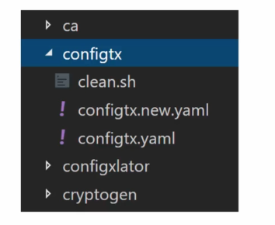

* all commands will be executed under this folder in the terminal

configtx gen is a command line utility for managing configuration artifacts.

There are **three types of artifacts** that you can manage with config gen.

1. **genesis block->** which is the order channel block used by the order binary.
2. **Create channel transaction->**So when you have to create an application channel, you can use the config gen to create the channel transaction.
3. **anchor peer update transaction->**This is for managing the anchor peers for the organizations that are part of the network.

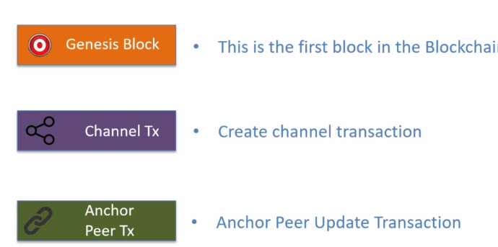

Please note that the third artifact type is not needed in fabric 2.0.

As a result, the configtxgen option for generating the peer update transaction is now deprecated It is still supported by the tool, but in later versions it may be removed.

The tool exposes **two type of commands:**

1. **output commands->**These output commands generate the configuration artifact.

* These commands require you to provide the configuration parameters in a file which is in Yaml format.
* So as a developer or as an administrator, you would put together a config.yaml file which will have all the parameters and the values.
* This file is used as an input to the config gen tool and that generates the required configuration artifact.

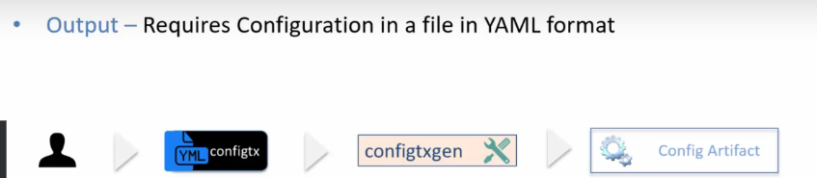

1. **inspection commands->**outputs configuration as JSON

* The generated configuration artifacts are files.
* They are in **binary format**, so you cannot open those files in a text editor
* in order to review the information contained in the configuration artifact files, you need to convert them to Json.
* And to do that you would use the inspection commands exposed by configtxgen utility.
* The configtxgen tool does not have any dependency on the runtime.
* In other words, to execute the configtxgen command, you don't need to have the fabric network up and running,
* No orders or peers are connected to by the config gen tool.
* the config gen tool simply generates the files and these files are in binary format.
* Now the one question that may occur to you at this point is why is it that the config gen is not interacting with the fabric runtime to execute these transactions?
* And the reason is that sometimes policies associated with the network govern the number of signatures that are needed for executing a transaction.
* For example, if the policy states that addition of organization requires organization A and organization B both to sign, then in that case the transaction generated by the config gen tool will need to be signed by the two organizations.
* So to illustrate this scenario, you will create the transaction file and then you will have the org A admin and org B admin sign that transaction file and then one of the admins will submit that transaction to the network for execution.

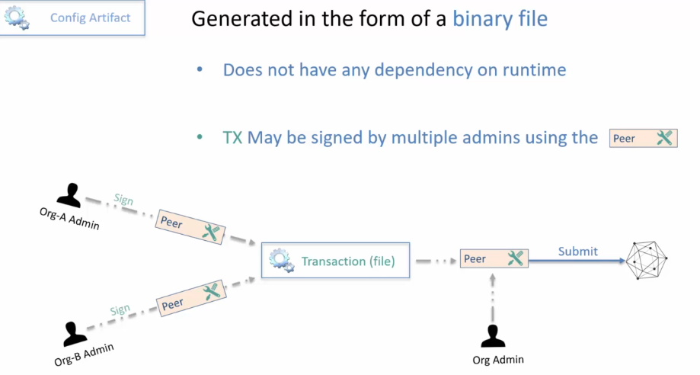

* The configtxgen tool is a command line tool.
* That is, there is no graphical interface to the tool.
* You would execute the configtxgen commands on the command shell window or the terminal window.
* The format of the command is configtxgen, you provide the command name and then you provide some optional flags and arguments
* to get help on configtxgen tool you can use the command dash help and to get the version you can use the command dash version.

1. command configtx version and you get the version information and
2. to get the help simply use dash help.

**Command to run in terminal->**

1. configtx version

2. configtx -help

In this section you will learn about:

how to set up the configtx.yaml file and then

all the commands on the configtxgen tool for generating the various configuration artifacts such as **the Genesis block, create channel transaction,anchor peer update transaction**

you would be in a position to create your own configurations using the config gen tool.

**Setting up the configtx.yaml file**

**Configtx YAML Profiles Section**

**Generating the Genesis Block**

**Generating the Create Channel Transaction**

**Generating the Anchor Peer Update Transaction**

**Exercise-Setup a new Channel Profile with 2 Orgs**